Adding additional stepper motors to the MKS Base 1.2 board using the
Arduino CNC Shield V3

NOTE: This is a work in progress. I am adding a diamond hotend to my tarantula and I wanted to document my findings. Currently I have gotten to the point of controlling my x-axis motor through the board by changing the X-axis pins.

The cnc shield I used is below:
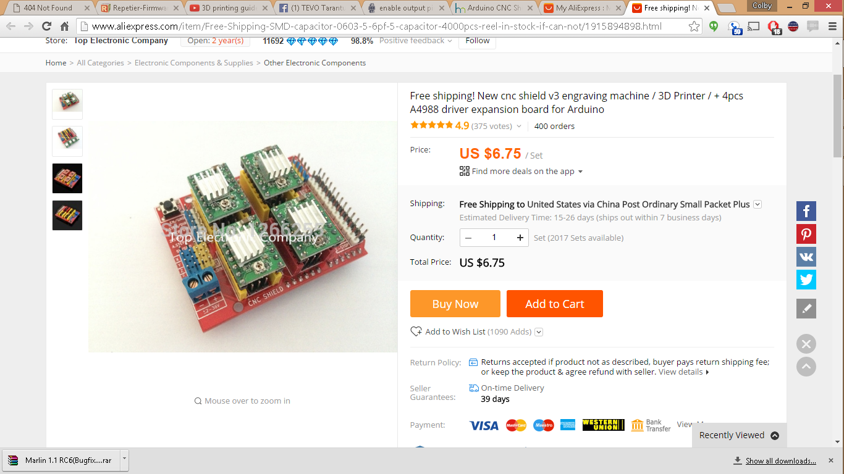
Step 1: Connect two wires from the 12 V power supply to the 12V terminal on the cnc shield (the blue terminal)

Step 2: Connect two wires from the AUX 1 port 5V and GND pins to the 5V and GND pins on the cnc shield (on the left row of yellow and blue headers). These can really be connected anywhere on the board that has 5V and ground. The unused endstop connectors also work. See the diagrams below.

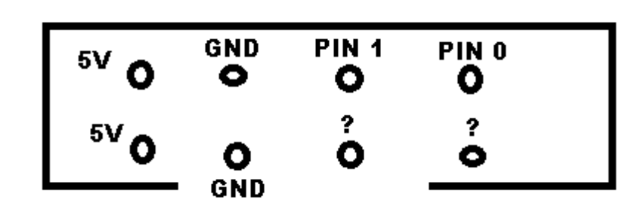Figure 1: AUX 1 port

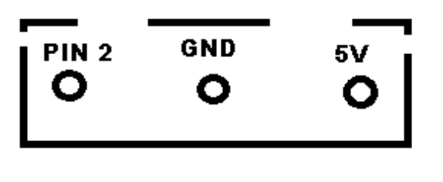Figure 2: X-maxEndstop ports
Step 3: Connect a wire from the “Y enable” pin on the cnc shield to pin 1 on the AUX 1 port (Figure 1). This will go to 0V when the motor is enabled, and 5V when it is disabled. This really threw me off when I was testing... You can connect it directly to ground to enable the motor all the time, if you want to test it.

Step 4: Connect a wire from the “Y step” pin on the cnc shield to pin 2 on your X-max endstop port (Figure 2)

Step 5: Connect a wire from the “Y dir” pin on the cnc shield to pin 0 on the AUX-1 port (Figure 1).

Step 6: Connect the motor to the CNC shield Y axis pins (next to the motor driver). You might have to mess around with the order of the wires to get it to work. Look up how to wire steppers and you should be able to figure it out.

Step 7: You need to remove the motor driver from the cnc shield and put some jumpers on the pins underneath it. This will set the microstepping. You want to set it to 1/8 stepping by putting a jumper on the first two pins from the left. You can look up more info here: http://blog.protoneer.co.nz/arduino-cnc-shield-v3-00-assembly-guide/

Step 8: Follow http://reprap.org/wiki/Adding_more_extruders . There is a section at the end for the CNC shield. Make sure to use the pin numbers above for the enable, step, and direction pins. I am using the Repetier version for dual extruders, provided by TEVO here: http://tevo3dprinterstore.com/

Some findings / notes / info:

I used individual header pin connectors for my jumper wires. These are crimp on, and pretty easy to use. You don't need a special crimping tool, just the universal one. I just crimped on the metal piece and then put shrink wrap around it.

Some digital pins are PWM, and some are other types. I'm not sure if it makes a difference, but pin 2 on the X-max endstop port is a PWM pin so I used it for the step pin. More testing to come to see if it works with non-PWM pins. Y-Max is connected to pin 15, which is RX3 type, and Z-max is connected to pin 19, which is RX1 type. I am going to test these out to see if they still work.

Here's the ATMEGA2560 pinout: https://www.arduino.cc/en/Hacking/PinMapping2560
I used a multimeter to find out the pin numbers for the AUX-1 port. Pin 1 is connected to R26, which is connected to the AUX-1 port. Pin 2 is connected to R27, which is connected to the AUX-1 port.

IMPORTANT NOTE: One of the other things that threw me was that nothing worked when the thermistors weren't connected. Make sure they are all connected when you are testing or else nothing will work.

